**Oracle SQL Developer Setup**

Use the following link to download Oracle Developer:

[Oracle SQL Developer Downloads](https://www.oracle.com/tools/downloads/sqldev-downloads.html)

Choose the proper download compatible to your OS.

For instance, if your OS is Windows_X64 choose the first option to download.

Windows 64-bit with JDK 8 included

If you have MAC, download the MAC version, you also need to download the JDK and install it. You can find the link to JDK on the Notes column.

**Setting the Java Path** (only required for those not using Windows 64-bit with JDK 8 included)

After having installed JDK, set the Java Home using whichever below link is applicable for you:

Windows OS - <https://javatutorial.net/set-java-home-windows-10>

Mac OS - <https://mkyong.com/java/how-to-set-java_home-environment-variable-on-mac-os-x/>

**Install SQL Developer**

Decompress the file and execute the sqldeveloper.exe

…\sqldeveloper

If you have any problems with the font size of the SQL DEVELOPER program (menu bar and navigation panel, and …) go to the following link for the instructions to fix the problem:

<https://christian-gohmann.de/2018/10/25/running-sql-developer-on-high-dpi-screens/>

When you have SQL Developer running, you need to create a new connection to connect to Seneca Oracle.

**To create a new connection**

* Connection Name: DBS211 (or any name you want)
* Your Oracle username and password: available under **My Grades** from the left course menu on Blackboard



* Select the “Save Password” checkbox
* Host name: **myoracle12c.senecacollege.ca**
* Port: **1521**
* Service name: **oracle12c**
* Click Test button, it should show Success at the bottom left corner
* Click on Save and then Connect

Figure 1

**Now you have already created the schema**

Once you have created the schema, if you see any table(s) under “Tables” in your DBS211 connection, you need to remove them first and then follow the instructions to create correct tables and data in your database.

**To Remove Tables**

1. Right click on the table name in the navigation panel and select “Table” and then select “Drop”.

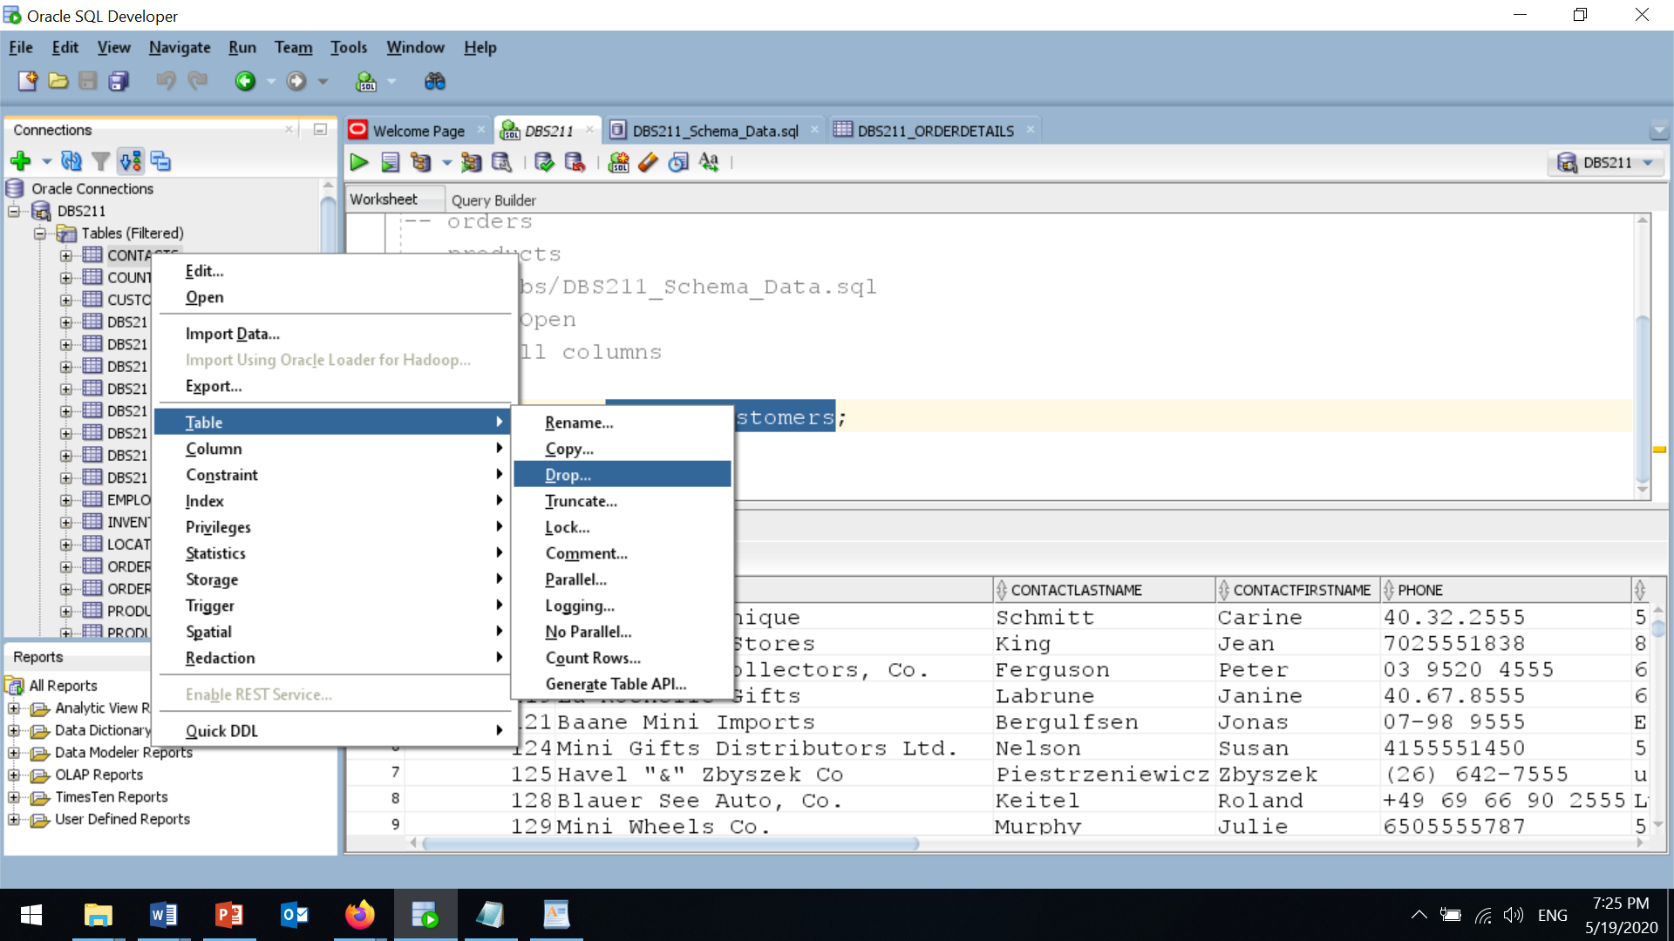

Figure 2

1. In the “Drop” page, check “Cascade Constraints” and click on the “Apply” Button.

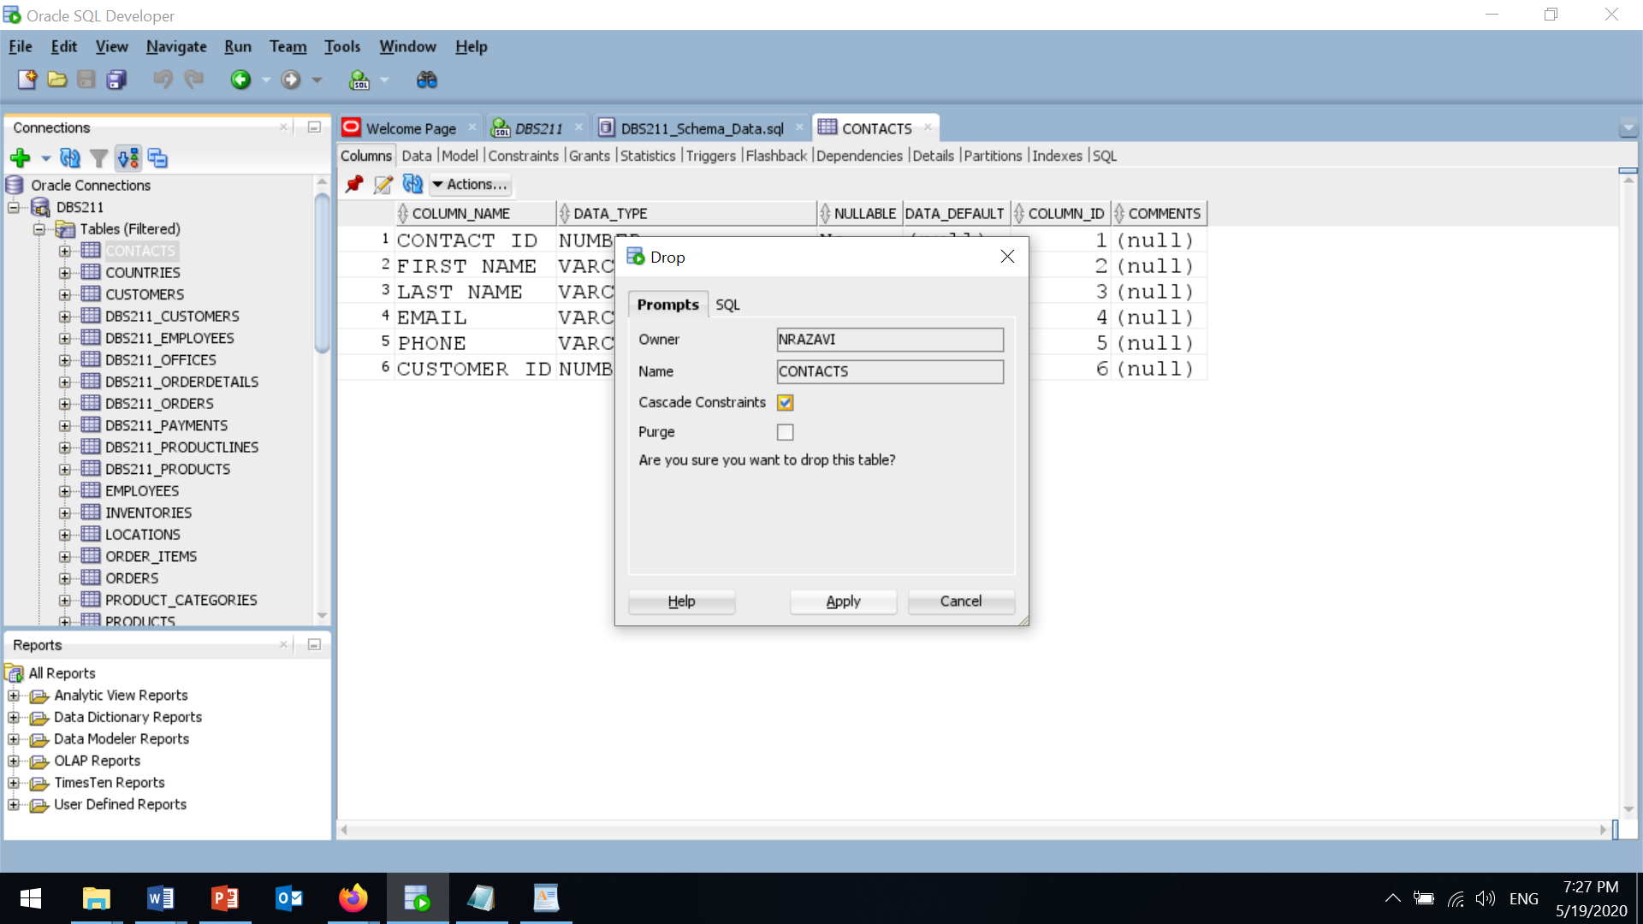

Figure 3

Repeat this to drop (remove) all tables first and then create the correct tables following the instructions below:

**Schema (Create Tables and Insert Data)**

To create the schema tables and insert data, download and execute the script from the below link:

[dbs211.ca/docs/DBS211_SampleDB_CreationScript.txt](http://dbs211.ca/docs/DBS211_SampleDB_CreationScript.txt)

Copy the whole script from the above webpage to the editor in SQL Developer:

1. Select the whole script and hit the “**Run Script (F5)**” icon (the icon next to the green triangle) to execute.

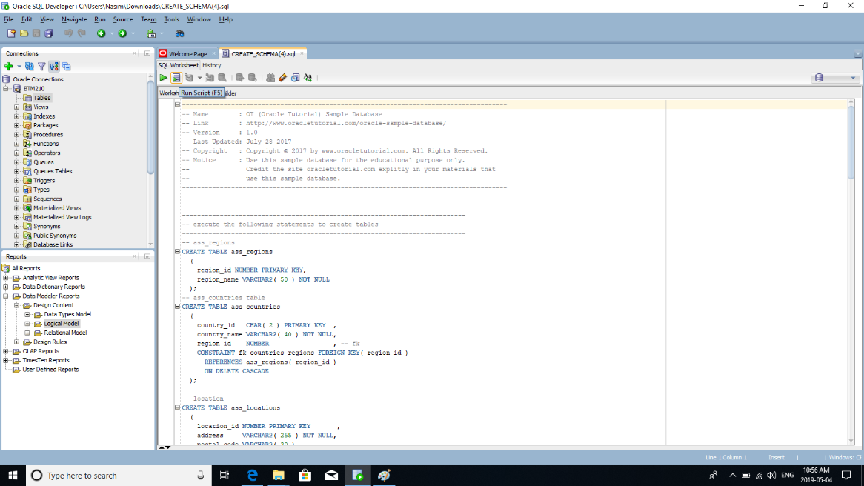

Figure 5

1. If you encounter a drop-down list, select the connection that you have created at the beginning of this lab and hit **OK**.

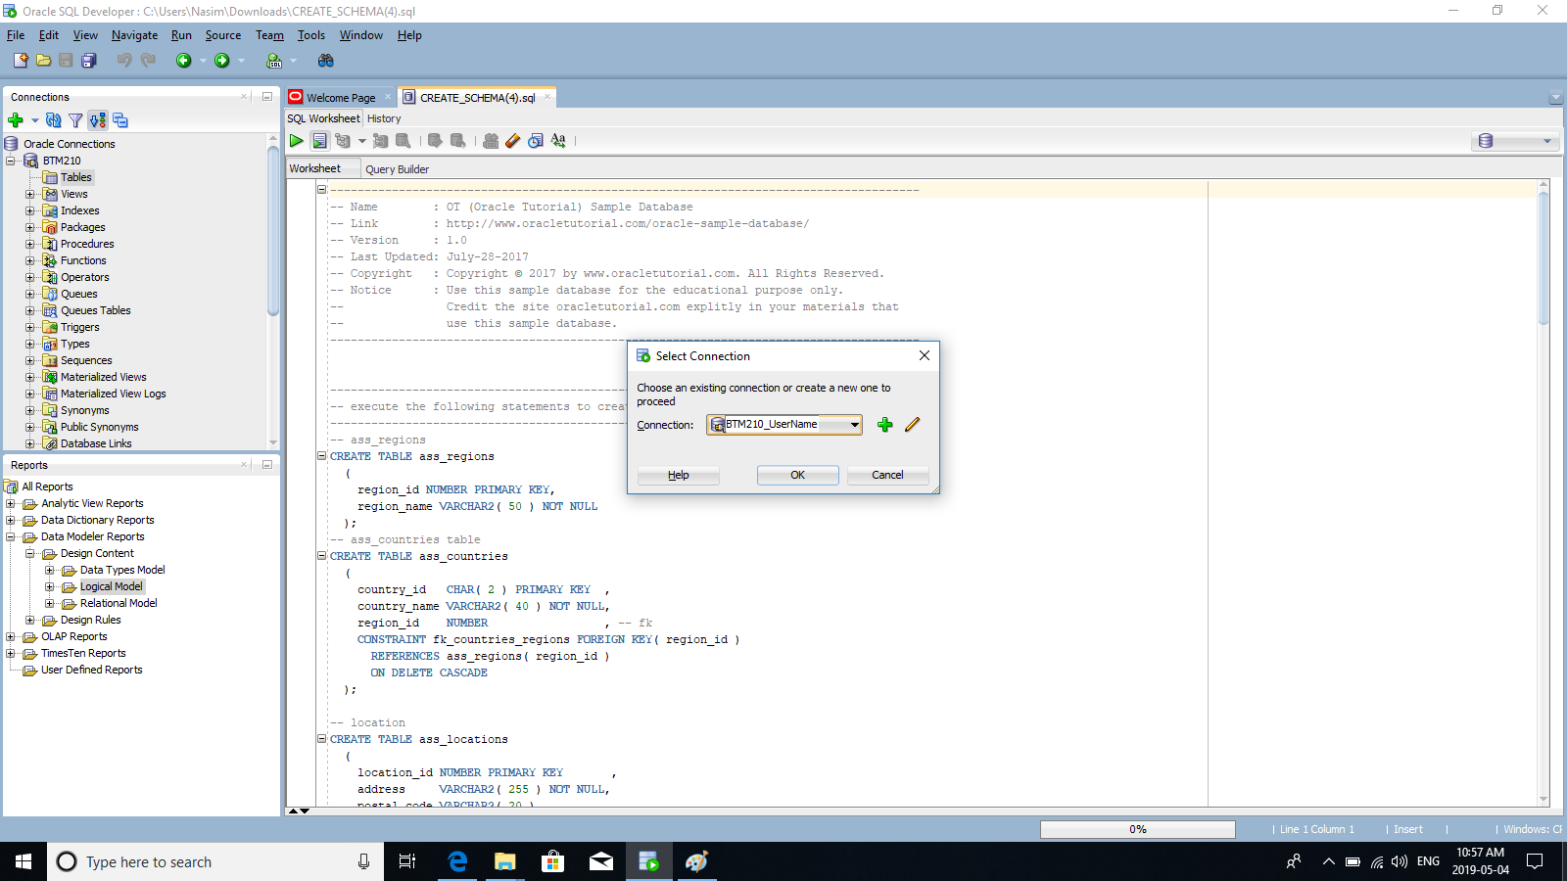

Figure 6

After all tables are created, you may not see the tables under “Tables” in the navigation panel. Right click on “Tables” and select “Refresh”. Now, expand “Tables”. You should see the following tables:

CUSTOMERS

EMPLOYEES

OFFICES

ORDERDETAILS

ORDERS

PAYMENTS

PRODUCTLINES

PRODUCTS